Summary for pre-read

WBR - Summary (for Pre-Read)
1) DLD Market
Both Primary and Secondary declined in value and volume in the first week of March, due to the impact of the recent US-Iran conflict. However, the decline was steeper in Secondary, as Primary had been growing faster than Secondary in Jan–Feb 2026 (similar to 2025). Going forward, if conflict drags on, Primary may be more impacted than Secondary.

2) Commercial
Sales Forecast: March previous view was 95% (with upside to 101%). Current view: 66% FC for March (upside to 69%). Situation’s evolution will impact both risk and upside.

3) Demand
SoS: Overall SoS at 47.8% (-0.3pp WoW). Web SoS at 49.7% (-0.7pp WoW), App SoS at 45.7% (-0.8pp WoW). All significantly below prior month (MTD 47.5% vs 50.9% last month, -3.4pp).
SEO SoV: Total at 45.3% (+3.9pp WoW), strong gains in Rent at 53.8% (+7.1pp WoW) and Generic at 32.7% (+2.35pp WoW). Buy slightly down at 63.0% (-0.7pp WoW).
Data Governance: Internal data was unavailable due to issues with Kochava and CHEQ implementation, hampering DRI’s ability to conduct deepdives

4) New Projects (Primary)
New Projects gross revenue ($111.4K) impacted by regional conflict with all metrics in red. Sessions at 43.3K (-36.5% WoW), Sold Leads at 1,067 (-45.8% WoW), Gross Revenue at $111.3K weekly (-42% WoW). However, no panic observed: demand metrics trending upward since March 2nd, and Primary Plus campaigns only dropped 3% since start of conflict.
Media & Developers: Forecast remains in red at 29%. New budgets are on hold until further notice.

5) B2C App
Metrics unavailable due to issue with Kochava
6) B2C Tech
App stability: Android Apdex at 95.07% and iOS Apdex at 95.40%. Both metrics have recovered retrospectively
Mobile INP Good rate at 69.5% vs 72% target (-0.5pp WoW). Decline driven primarily by Search Results Pages (~6% latency regression) and Search Landing Pages. Property Listing Pages remain stable and performant. Volatility concentrated on search templates, not systemic across platform.
7) B2B Performance
Incident Volume: P0: 0 (vs 5.6 target), P1: 11 (vs 67.3 target) - continuing strong trend well below targets
B2B Agent App: Both App active agents (11.2k) and WAU (2.9k) are under target by 25% and 56% respectively)

DLD Market Growth

Property Finder
Weekly Business Review

Market (Dubai)
- Both Primary and Secondary declined in value and volume in the first week of March, due to the impact of the recent US-Iran conflict. However, the decline was steeper in Secondary, as Primary had been growing faster than Secondary in Jan–Feb 2026 (similar to 2025).
- And the full impact of the conflict is yet to reflect in the data and may take another 2–3 weeks. Current transaction value trends largely reflect past transactions that are only now getting registered with the DLD.
- Going forward, if conflict drags on, Primary may be more impacted than Secondary.

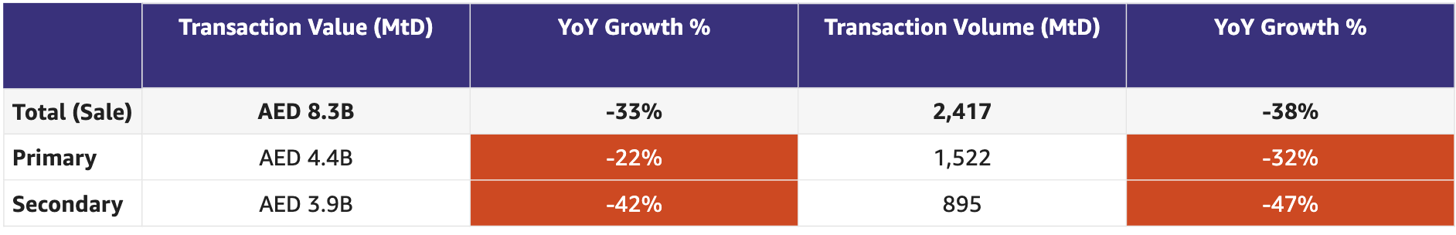
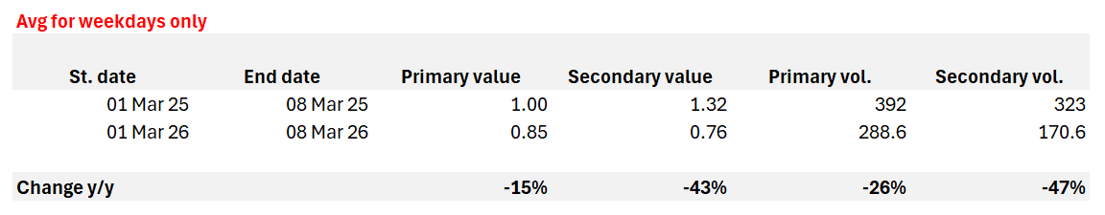
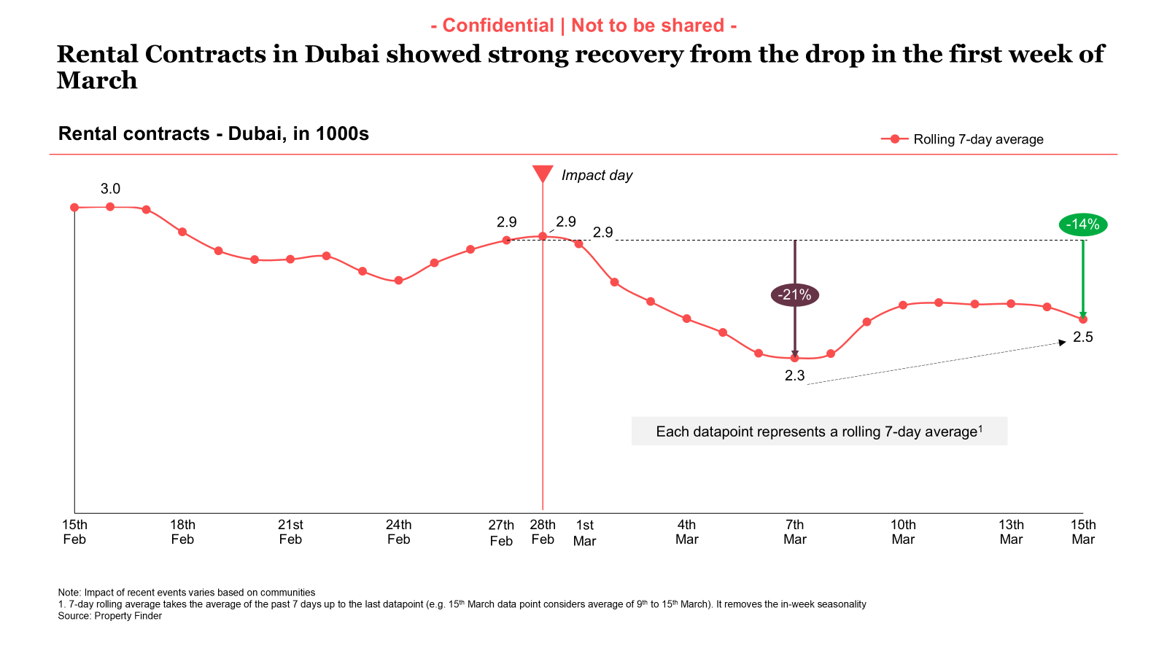
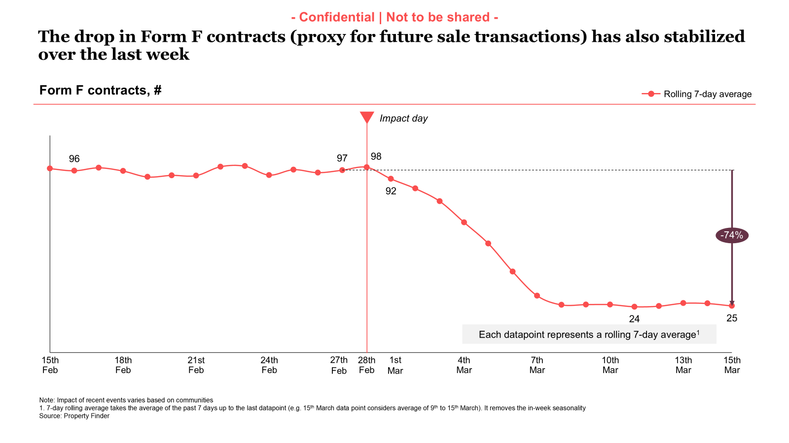
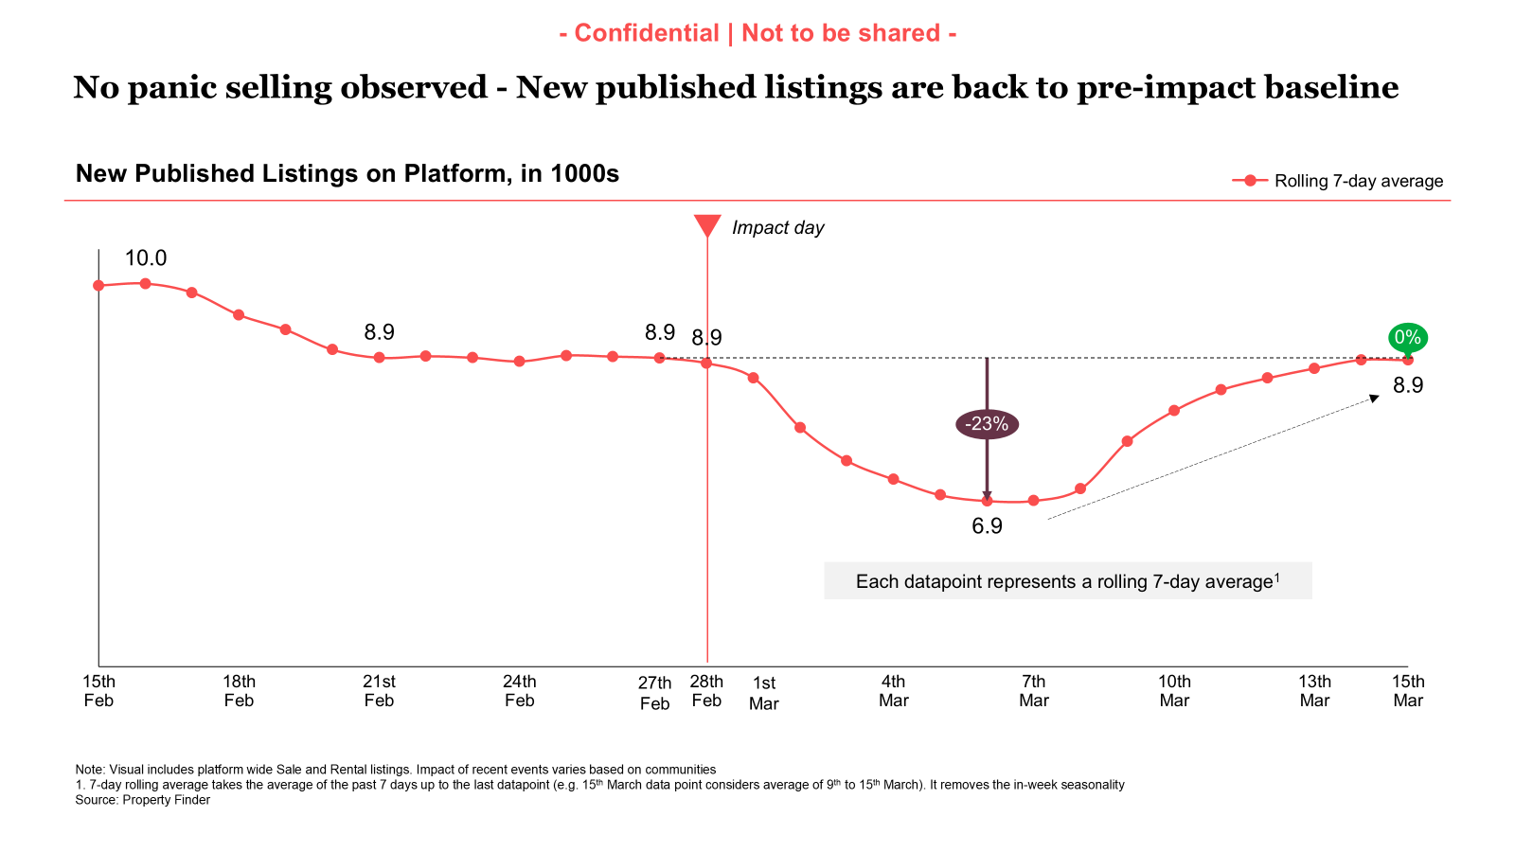

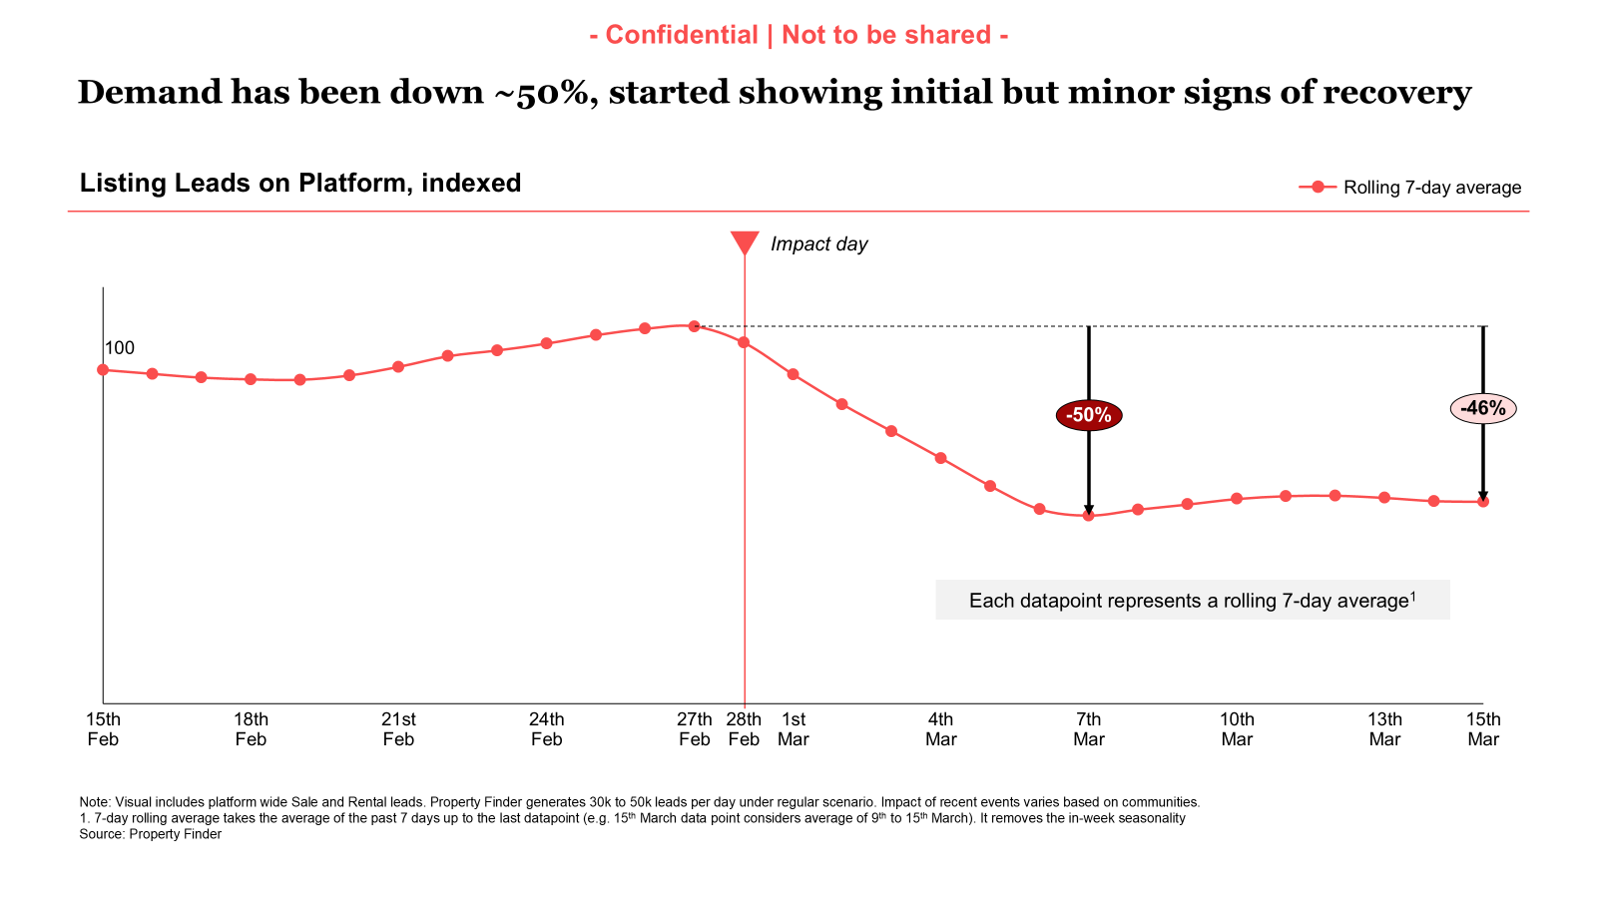

Commercial

Commercial
Category | DRI | Which metric is red and why | Actions planned | ETA for target achievement
Sales forecast % | Vladimir Malugin | March previous view: 95% (with upside to 101%)  CURRENT VIEW:  66% FC for March (upside to 69%) - sales have identified main risks. Similar levels for April.  Continuation of hostilities is resulting in more downside and reducing upside.  Concerns around cashflow for next few months are still top of client minds | Continued focus through following initiatives, while recognizing key risks:  - Account Plans  - Renewal Narratives  - Relief Program Offers (Next week)  MITIGATION:  - March Relief - in action  - April and onwards relief programme - to be announced next week  - Anti-crisis broker playbook - Commercial town hall today. Key bullets:  - Leads and deals are not gone - there is less  - Time to nurture them more to close in 2-3 months  - If you are not in the market - you are not competing for sellers and buyers that are here
Exclusive Listings | Michelle Brackley | Rebaselined data is available in the dashboard. We are currently working on finalising targets  80% of missing ORN and RERA numbers corrected in SF | Updates from last weekly meeting:  1. Non-Compliant Listings  Confirm current notification logic and how we can enable notifications to agents/admins  Owners: Pascal/Saif  Next Steps: Create as-is and to-be comms flow  ETA: 18/03/26  2. Automatic Import of BY Exclusive Listings on Expert  Owners: Hugs  Next Steps: Demo with BCs and CSPs  ETA: 18/03/26  3. CPL Discount on BY Exclusive Listings  Owners: Anirudh  Next Steps: Design review meeting (internal)  ETA: 18/03/26  4. Milestone-Driven Benefits (incl. SuperAgent Points – “First to PF”)  Owners: Hugs  Next Steps: Review initial ideas, align on inputs required from BA team and close first draft of proposal  ETA: 18/03/26  5. Compass Data Narrative  Owners: Aksinia  Next Steps: Listings data to go live in Compass  ETA: 26/03/26  6. Community Ranking Methodology  Owners: Volkan/Yash  Next Steps: Exclusive listings will be incorporated into the methodology  7. Community Performance Marketing  Owners: Mahmoud/Michelle  Next Steps: Align on communities to target for performance marketing campaigns  ETA: 25/03/26  8. Collateral for Exclusive Listings  Owners: Pascal/Michelle  Next Steps: Michelle to share requirements with Pascal  ETA: 25/03/26

Weekly Metrics
 |  | Weekly |  |  |  | MTD (Feb)
Category | Metric | Week  (Actual) | Week (Target) | WoW | vs 2 weeks prior | MtD  (Forecast) | Month (Target) | vs MtD  prev month (MoM) | vs MtD  prev year (YoY) | vs competition | DRI | Dash
Sales  (MtD) - UAE | Sales Forecast %  (Month-end) | Monthly -> |  |  |  | 46.5M  (66%) | 70.6M | Not Applicable | Not Applicable | Not Applicable | Vladimir Malugin | Link

CLEL to not be discussed in Q1, till baseline is defined and Product actions are in place

Category | Metric | Week  (Actual) | Week (Target) | WoW | vs 2 weeks prior | MtD  (Actual) | Month  (Target) | vs MtD  prev month (MoM) | vs MtD  prev year (YoY) | vs competition | DRI | Dash
Net exclusive listings | Rent | 4.6k | NA | 5.9k  (-1.3k) |  | NA | NA | NA | NA | Not Applicable | Michelle Brackley
 | Sale | 10.4k | NA | 12.2k  (-1.9k) |  | NA | NA | NA | NA | Not Applicable | Michelle Brackley
Supply | Net Exclusive Listings | 15.0k | NA | 18.2k  (-3.2k) |  | NA |  | NA | NA | Not Applicable | Michelle Brackley

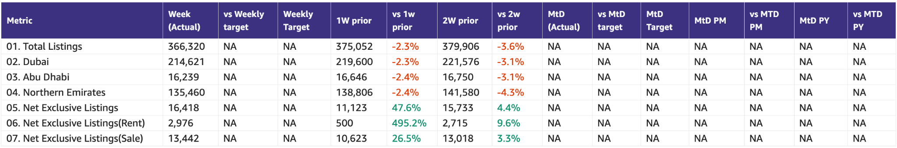

Primary (NP, Media, Dev)

Primary (New Projects, Media Sales)
Category | DRI | Which metric is red and why | Actions planned | ETA for target achievement
New Projects | Enguerran Milhiet | - All metrics in red, impacted by the regional conflict.  - However, no panic observed:  - The trend of demand metrics is upward since March 02nd.  - The number of Primary Plus campaigns only dropped 3% since the start of the conflict. | - Continue SEO initiatives (footer content in the developer list, update project description with SEO-friendly keywords, revisit META Title/Description content, Internal Links) => impact on sessions and leads  - Launch smart leads on March 23 => impact on sold leads (conversion)  - Halt on price changes to avoid any misperception from clients. | - Expected to achieve 90% of Primary Plus revenue in March.
Media & Developers | Sami Awada | - The forecast remains in red at 29%. New budgets are on hold until further notice | - Focus on active campaigns and push delivery | - 1.6M in upside remains positive as of this week

Category | Metric | Week  (Actual) | Week (Target) | WoW | vs 2 weeks prior | MtD  (Actual) | Month  (Target) | vs MtD  prev month (MoM) | vs MtD  prev year (YoY) | vs competition | DRI | Dash
New Projects | Sessions | 43.3k | 87k | -36.5% | -45.5% | 47.1k | 385,454 | -47.6% | -58.7% |  | Enguerran Milhiet
 | Sold Leads | 1,067 | 1,787 | -45.8% | -47.7% | 1,197 | 7,910 | -35.2% | +1.3% |  | Enguerran Milhiet
 | Gross Revenue (USD) | $111.3k | $130.6k | -42% | -40.7% | $123.2k | 578,237 | -26.9% | +26.5% |  | Enguerran Milhiet
Media & Developer | Revenue from Media Products | NA | NA | NA | NA | Monthly |  |  |  |  | Sami Awada

Demand (Paid/Unpaid)

Demand
Category | DRI | Which metric is red and why | Actions planned | ETA for target achievement
Paid | Ahmed Osman | - N/A | Summary (15 Mar 2026):  - Demand: Sessions index is currently 71 (baseline = 100), still 29pts below baseline but +12.6% WoW, indicating gradual recovery.  - Spend: Pre-conflict spend averaged $34.5K/day. The last 7-day average is $25.5K/day (-26% vs pre-conflict), trending upward as channels are reactivated.  - Leads: Recovery continues across both channels, Paid +18.9% WoW, Organic +11.1% WoW.  Next Steps:  - Cost Adjustments: All reactivation signals (stable sessions, lead recovery, strong paid search SOV) have been met, and we are gradually ramping spend across platforms, while monitoring cost and conversion rate stability.  - Messaging: Our BAU catalog ads are running alongside transaction-focused messaging to capture users looking to understand price movements in the current market environment.  - Risk Monitoring: Under our Ads Sensitivity Response Protocol, we are monitoring searches related to Arabian Ranches and Dubai Marina following rumors of potential attacks. If search spikes occur, we will pause ads on related queries to protect media investment. | - N/A
Unpaid - SEO | Mahmoud Nessim | - Overall SoV, is reaching all time high, and still on a positive trend  - Buy SoV shows a slight decrease, mainly due to fluctuations from SEMrush as a tool  - Generic KWs being sub-50s is intentional as generic KWs holds high volume and low clickability ( e.g when someone searches for Dubai Marina they rarely click on Bayut or PF ), and the fact that it’s a high volume KW, means it a high effort hence we’re optimizing for KWs that brings sessions, and later for generic ( Also doesn’t mean we’re not growing on generic too ; ) ) | - Launching UGC on PLPs, SERPs and New projects to scale content production  - Scaling internal links from blogs to key SERPs,  - Scaling the content production with more advanced models and workflows | - Get the placement secured in the SERPs substituting new projects slot (CC: Enguerran Milhiet ) (EoW)  - Integrating the listings/DLD/POI data for content enhancements (Early April )  - Shipping the internal linking algorithm (Early April )  - Shipping footer content revamp by ( Mid April for final rollout, Dubai )
Unpaid - Overall | Soumar Aoun |  | Shipping this week (structural impact)  Price Per Area  - Web PLP — 13/03  - Web SERP — 16/03  - Apps PLP — 16/03 (TBC)  - Apps SERP — 18/03 (release train)  Revamps  - SERP revamp web - 16/03  SERP Enhancements (Apps)  - Floor Plan on SERP — 18/03 (release train)  - Video on SERP — 18/03 (release train)  Conversion / Login  - Updated Save Alert ingress to drive login  Delayed / shifted  - Floor Plan on SERP (Web) — delayed due to contractor issues  - CTAs on Recommended Properties on PLP (Web) — delayed as engineer had to prioritize Price per Area after contractor sickness  - Enabling Search Re-engagement for New Projects — shifted to 18/03 due to limited backend capacity  Ramped Down (CRM)  - WhatsApp login — ramped down due to A/A test
Exposure LPL | Paresh Goyal | - Data unavailable | - Q2 eLPL targets to be reset to align with actual market growth (Ashish)  - CRM Initiatives Update  - Top Picks (Targeted Recommendations): De-prioritized due to capacity constraints, will be taken up in Q2 planning  - Search Re-engagement – Biased Exposure Listings is on track  ETA: 30 Mar.  Channels: Push & Email. | - NA

1. SoV - SEO

Metric | Week (Actual) | 1W prior | vs 1W prior | 2W prior | vs 2W prior | MtD (Actual) | MtD PM | vs MtD PM
Total | 45.3% | 41.4% | 3.9 | 41.8% | 3.5 | 44.8% | 41.5% | 3.3
Buy | 63.0% | 63.7% | -0.7 | 64.4% | -1.4 | 61.8% | 69.0% | -7.2
Rent | 53.8% | 46.7% | 7.1 | 48.0% | 5.8 | 52.9% | 49.3% | 3.6
Generic | 32.7% | 30.4% | 2.35 | 30.8% | 1.97 | 32.5% | 27.5% | 5.1

2. Share of Sessions

Platform | This week | Last week | vs last week | 2 weeks | vs 2 weeks | MTD | Last month | vs last month | Last year | vs last year
Total | 47.8% | 48.2% | -0.3 | 46.7% | 1.2 | 47.5% | 50.9% | -3.4 | 55.9% | -8.4
WEB | 49.7% | 50.4% | -0.7 | 48.5% | 1.3 | 49.4% | 48.5% | 0.9 | 51.2% | -1.8
App | 45.7% | 46.5% | -0.8 | 45.2% | 0.5 | 45.5% | 53.2% | -7.7 | 60.4% | -14.9

WEB channel splits are not available on a daily level

App
Device category | This week | Last week | vs last week | 2 weeks | vs 2 weeks | MTD | Last month | vs last month | Last year | vs last year
IOS | 42.0% | 44.3% | -2.3 | 41.3% | 0.7 | 42.0% | 49.3% | -7.3 | 51.1% | -9.1
Android | 48.2% | 47.8% | 0.4 | 47.7% | 0.5 | 47.9% | 55.9% | -8.1 | 65.7% | -17.9

App DAU

Device category | This week | Last week | vs last week | 2 weeks | vs 2 weeks | MTD | Last month | vs last month | Last year | vs last year
Total App | 53.0% | 58.1% | -5.1 | 54.3% | -1.4 | 53.3% | 59.4% | -6.1 | 55.8% | -2.5
IOS | 49.7% | 54.8% | -5.1 | 51.1% | -1.4 | 50.1% | 56.1% | -6.0 | 48.4% | 1.6
Android | 55.0% | 60.2% | -5.1 | 56.3% | -1.3 | 55.4% | 61.5% | -6.0 | 60.0% | -4.6

3. Demand Funnel
(Direct and SEO Data are currently being fixed under Data Governance Workstream)

Web - Paid

App - Total

Exposure LPL
(EXCLUDES DIRECT)

Leads and Listings distribution

Rent vs Buy Split

Monthly Metrics

B2C NPS
Category | Metric | MtD  (Actual) | Month (Target) | vs MtD  prev month (MoM) | vs MtD  prev year (YoY) | vs competition | DRI | Dash
B2C NPS | B2C NPS | 4 | Not Available | 3 | 19 | Not Available | Alson Dsouza

Leads click to delivered:
Category | Metric | MtD  (Actual) | Month (Target) | vs MtD  prev month (MoM) | vs MtD  prev year (YoY) | Δ vs Competition | DRI | Dash
Leads Funnel | Total Leads Delivered (WA) |  |  |  |  | Not Available | Soumar AounSruthi Poduval | Link
 | % Clicks to Delivered (WA) |  |  |  |  | Not Available | Soumar AounSruthi Poduval | Link
 | Error Leads (WA) |  |  |  |  | Not Available | Soumar AounSruthi Poduval | Link

PR Metric
Category | Metric | MtD  (Actual) | Month (Target) | vs MtD  prev month (MoM) | vs MtD  prev year (YoY) | vs competition | DRI | Dash
PR | PR Sov | 88% | 50-55% |  | [...] | [...] | Natalie Faulkner | PR team

- Competition
  - Share of Session (Overall, Web Channels, App Channels)
  - SoV - Paid click share

- Demand Funnel
  - Sessions (by channels)
  - Leads (by channels)
  - CR (by channels)
  - Click to Delivered

- Exposure LPL
  - Overall / Rent / Sale
  - Top Communities
  - Web/App
  - Exposure Leads as % of Total Leads (Overall / rent / sale)
  - Exposure Listings (Overall / rent / sale)

- Engagement Metric (Time on site)
- B2C NPS -
- PR SoV - We remain firmly in green due to some philanthropic news
- Leads split by Rent vs Buy

Data Governance

DATA GOVERNANCE
Problem Name | Problem Description | Latest update | Resolution update (ETA) | DRI
Kochava vs Redshift | Sessions in Kochava significantly overreported in Redshift compared to Kochava | DE team working on the fix  1. iOS leads gap : ~5% of days outside threshold in Y26 (minor variance).  2. Sessions discrepancy at geo country level (DE-7969): ~35% of days outside threshold range  3. User metrics table inconsistencies (DAU, WAU, MAU) (DE-7970): Significant discrepancies (2x)  4. Other downstream app tables | 23-01 | Uday KasettyAshish Khurana
GA4 vs Redshift | Sessions and leads significantly overreported in Redshift compared to GA4 | DE team working on the fix:  • Overall leads discrepancies (DE-7962): On 1/3rd of the days (Y26), leads discrepancy is beyond the agreed threshold  • Channel-level mismatches (DE-7962): Outlined in the ticket  • Other downstream web tables: To be fixed | 23-01 | Aamir ShaiqAshish Khurana
Spam Issues | Unrealistic spike on sessions and lead clicks since September 2025  Reported delivered spam leads from Pakisting and India | 1 Remove spam activity from all reporting tables across both GA4 and Snowplow leveraging third party tool (Cheq) - completed  2 Define tech solution to block “bad” spam activity so it can be prioritized during Q2 roadmap planning - completed  3 Assess the feasibility to leverage cheq spam classification into delivered leads spam detection model - WIP. Not feasible, other short term options under discussion | 1 - 09/03  2 - 06/03  3- 03/03 | 1. Wael AbdellaAamir Shaiq  2. Amory Kelie  3. Mercedes Modet
SEO (Sessions vs clicks) | SEO session not fully in line with Google Search console clicks | 1 Agreed on starting reporting SEO traffic as-is once spam activity is removed - completed | 1 - 09/03 | Aamir ShaiqWael Abdella
CRM Attribution Reporting | CRM sessions not in line with braze clicks | 1 Push notification  - iOS - completed  - Android - under investigation | 1 - 10/03  2 - no ETA | Wael SalloumHussein Zahran
Kochava Integration Update | Integration between Kochava and PF pipelines unstable | 1. Upgrade integration between Kochava and PF Expert - completed | 1 - 06/03 | Uday Kasetty
Non listing Leads | Spike on non-listing leads starting in January driven by lack of synch between old/new listing service during portal DB migration | 1. Web - completed  1. App - under investigation | No ETA | Aamir Shaiq
Credit consumption | 1 - Significant decline on credit spend in January and August  2 - 1-2% of “credit consumption” against listings that “never went live”  3 - Some of spotlight listings are not flagged as spotlight | 1 - completed  2 - Fix implemented, validation ongoing  3 - completed | 2 - 18/03 | Ahmed Malikand Aamir ShaiqMehmet Yusuf Cakmak

B2C App Engagement

B2C App
Category | DRI | Which metric is red and why | Actions planned | ETA for target achievement
App engagement & installs | Ahmed Osman
App ratings | Soumar Aoun

Weekly Metrics -
Data Unavailable

App ratings

- App Installs
- App MAU
- DAU/MAU
- Sessions / DAU
- Login Ratio
- Avg Session Duration
- Playstore rating (Android)
- Playstore rating (iOS)

B2C Tech Metrics

B2C App
Category | DRI | Which metric is red and why | Actions planned | ETA for target achievement
App stability & performance | Taran Kambow | Android: 95.07%  - Apdex drop was caused by force restarts, app hangs, and a viewed-properties crash (fixed in 13.45.0, deployed Mar 4), plus a Facebook login issue (fixed in 13.45.1, deployed Mar 9)  - Force restarts: Root causes identified. Some are false positives. Ad loading delays on SERP are a known trigger. Fix is ready and will be deployed on Mar 18, 2026.  iOS: 95.40%  - The Apdex improved by 0.17 compared with the previous week due to the adoption of versions above 14.44.1 (10653) which included the Luciq rollback.  - App hang: We have fixed an app hang identified through insights from Instabug that was occurring while loading Google Ads in the Search View. The fix is expected to go live on March 18. | Android:  - Fixes deployed on Mar 4th and Mar 9th  iOS:  - Fix to be deployed on Mar 18th
Web Stability & Performance | Amory Kelie | - Which metric is red and why  - Mobile INP Good Rate is 69.5% vs 72% target (-0.5pp WoW).  - The decline is primarily driven by Search Results Pages (~20% of interactions), which saw a ~6% latency regression this week.  - Search Landing Pages (~26% of interactions) also showed a modest regression.  - Core templates such as Property Listing Pages (~34% of interactions) remain stable and performant.  - The volatility is concentrated on search templates, not systemic across the platform. | - Auditing recent releases, feature flags and experiments impacting search templates  - Rolling back or optimizing non-critical JS impacting interaction latency  - Enforcing performance budgets on search templates (Landing + Results)  - Daily monitoring on high-traffic interaction surfaces | - Stabilise to 72% within ~2–4 weeks  - Reach 75% by end of Q2

 |  | Weekly |  |  |  | MTD
Category | Metric | Week  (Actual) | Week (Target) | WoW | vs 2 weeks prior | MtD  (Forecast) | Month (Target) | vs MtD  prev month (MoM) | vs MtD  prev year (YoY) | vs competition | DRI | Dash
Tech stability & Performance | Mobile INP Good rate (%) | 69.5 | 72 | -0.5 | +0.4 |  |  |  |  |  | Amory Kelie

- Appdex: Android
- Appdex score: iOS
- CWV

B2B Product

B2B
Category | DRI | Which metric is red and why | Actions planned | ETA for target achievement
CSAT (P0s) | Luis Cappa | Note: Throughout this weekly period, Bayut was down for 1 week and we were not despite the AWS downtime (e.g. Salesforce) challenges. This is thanks to Kill Bill related efforts completion (legacy platform was running in AWS UAE).  March continues with very low Incident Volume (P0s + P1s), with only 11 P1s and P0s from 1st to 8th March, and a total of 17 tickets MtD (16 P1s + 1 P0). | N/A | N/A
Agent Experience | Sajjad Ahmad | - Low against set targets for the week.  - However, week of 9 March we are seeing a recovery:  - Acquired users: 11332 (as of 14 March), 131 new users acquired  - WAU: 3370 (as of 14 March), up by wkly 440 users | No particular action plan, today Claim Transactions: Buyer Claims is launched for all Dubai clients, after a successful pilot with 32 clients. | N/A

Weekly Metrics
 |  | MTD
Category | Metric | MtD  (Actual) | Month (Target) | vs MtD  prev month (MoM) | vs MtD  prev year (YoY) | vs competition | DRI | Dash
CSAT | Incident Volume | P0: 0  P1: 11 | P0: 5.6  P1: 67.3 | P0: 0  P1: 13 | P0: 0  P1: 23 | Not Available | Luis Cappa | Link  (JIRA)

 |  | Weekly |  |  |  | MTD
Category | Metric | Week  (Actual) | Week (Target) | WoW | vs 2 weeks prior | MtD  (Actual) | Month (Target) | vs MtD  prev month (MoM) | vs MtD  prev year (YoY) | vs competition | DRI | Dash

Agent Engagement & Experience | App active agents | 11201 | -15.1%  (vs 12897) | +0.9%  (vs 11105) | +2.8%  (vs 10899) |  |  |  | Not Available | Not Available | Sajjad Ahmad | TBA
 | Active users per week (WAU) | 2930 | -34.4%  (vs 4466) | -18.5%  (vs 3590) | -17.5%  (vs 3549) |  |  |  | Not Available | Not Available | Sajjad Ahmad | TBA
 | Agent NPS | NA | NA | NA | NA | Monthly Metric |  |  |  |  | Sajjad Ahmad | TBA

Agent Engagement & Experience | Agent NPS | Monthly Metric |  |  |  |  | Sajjad Ahmad

Listing Quality

Monetization
Category | DRI | Which metric is red and why | Actions planned | ETA for target achievement
Compliance | Saif Al-Amid |  | - Continued to execute daily batches | - Refer to this slide for planned actions and timelines

Special Projects
Monthly Lookbacks

Converting at risk clients to Promoters Ivan Gregorc Status
- Expected achievement at the end of the quarter. Based on current progress, what’s the estimated achievement rate for the end of Q1 2025?
By end of Q1, we expect to convert 50%+ of Neutral/Detractor clients into Promoters (target= 15 promoters) and protect renewal risk across the Marketing-owned portfolio (20 clients). Assuming delivery on Product-dependent items.
Current status: 🟢Promoters: 9 🟡Neutral: 9 🔴Detractors: 2
- Achievement (till date) : Indicate completed and pending tasks.
- Client sentiment baseline established and tracked weekly
- Identified top 6 elements to turn Neutral clients into promoters
- Active engagement in place for all Target clients
Pending:
- Impediments : If applicable, what is delaying the progress?
- The majority of blockers are Product-dependent
- Some perception issues (Awards, Premium value) require time and repetition to shift
- Initiatives to address impediments: What actions will we take to address the above issues or improve results?
- 5 out of the 6 (SuperAgent Point System, Spam Leads, Split Deals, Agent Engagements,, Cost of Premium Listings) major issues brought up are being addressed by end March
- 1 out of the 6 (Draft listings Listings) was addressed
Link to deep dive document

Special Projects - Q1 OKRs
Keyper Soumar Aoun On Track
- Expected achievement at the end of the quarter. Based on current progress, what’s the estimated achievement rate for the end of Q1 2025?
  - Keyper integration across B2B and B2C flows is in progress, with the majority of core components in active development and the remaining work focused on final CX workflow alignment and commercial enablement.
Core integration is on track for completion by the end of March. A buffer period for end-to-end testing and launch readiness will follow, with go-live expected no later than 15 April 2025 with overall progress reaching ~95% completion by the end of Q1 2025.
- Achievement (till date) : Indicate completed and pending tasks.
  - 3 agencies selected for MVP launch
  - ~50% of Keyper implementation delivered and the rest is under progress
  - The CX team is working towards a joint CX workflow plan with Keyper.
  - Legal review of key agreements within the flow is ongoing.
- Impediments : If applicable, what is delaying the progress?
  - Design and development capacity constraints have impacted the pace of the integration.

- Initiatives to address impediments: What actions will we take to address the above issues or improve results?
  - Additional contractors onboarded to the B2C team to increase capacity and accelerate delivery
  - Prioritization of core integration components to ensure critical functionality is delivered on schedule

Bundles Paresh Goyal On Track
- Expected achievement at the end of the quarter. Based on current progress, what’s the estimated achievement rate for the end of Q1 2025?
  - MVP Product will be ready for launch in March
  - Pilot sales has been intentionally pushed out, given current market and client situation
- Achievement (till date) : Indicate completed and pending tasks.
  - Development work progressing on-track but with some impact from salesforce migration
- Impediments : If applicable, what is delaying the progress?
  - Salesforce system has just come back online and hence, salesforce development work had paused
  - Expected impact of 2-3 days in completing salesforce development and hence, delay in go-live from 24th March to 26th March
- Initiatives to address impediments: What actions will we take to address the above issues or improve results?
  - Working towards an approach to sign paper contracts for bundles and a potential way to manually switch on bundles for such clients

📋 Prev Saved Reports

Week | Date | Link
Week 9 | Feb 1 to Feb 28 | WBR - Week 9 - Feb Monthly Lookback (Saved Report) Metric Report
Week 8 | Feb 16 to Feb 22 | WBR - Week 8 (Saved Report) Metric Report
Week 7 | Feb 9 to Feb 15 | WBR - Week 7 (SAVED) Metric Report
Week 6 | Feb 2 to Feb 8 | WBR - Week 6 (Saved) Metric Report
Week 5 | Jan 1 to Jan 31 | WBR - Jan Monthly Lookback (Saved Report) Metric Report
Week 4 | Jan 19 to Jan 25 | WBR - Week 4 (Saved) Metric Report
Week 3 | Jan 12 to Jan 18 | WBR - Week 3 (SAVED) Metric Report
Week 2 | Jan 5 to Jan 11 | WBR - Week 2 (SAVED) Metric Report
Year End.
W52 | Dec 1 to Dec 30 | WBR Metric Report - Dec Monthly Lookback (Saved Report)
W49 | Dec 1 to Dec 7 | WBR Metric Report - Week 49 (Saved Report)
W48 | Nov 1 to Nov 30 | WBR Metric Report - Week 48 - Nov Monthly Lookback (Saved Report)
W47 | Nov 17 to Nov 23 | WBR Metric Report - Week 47 (Saved Report)
W46 | Nov 10 to Nov 16 | WBR Metric Report - Week 46 (Saved Report)
W45 | Nov 3 to Nov 9 | WBR Metric Report - Week 45 (Saved Report)
W44 | NA | NA
W43 | Oct 1 to Oct 31 | WBR Metric Report - Week 43 - Oct Monthly Lookback (Saved Report))
W42 | Oct 15 to Oct 21 | WBR Metric Report - Week 42 (Saved Report)
W41 | Oct 8 to Oct 14 | WBR Metric Report - Week 41 (Saved Report)
W40 | Oct 1 to Oct 7 | WBR Metric Report - Week 40 (Saved Report)
W39 | Sep 1 to Sep 30 | WBR Metric Report - Week 39 (Saved Report)
W38 | Sep 17 to Sep 23 | WBR 2.0 Report - Week 38 (Saved Report)
W37 | Sep 10 to Sep 16 | WBR 2.0 Report - Week 37 (Saved Report)
W36 | Sep 3 to Sep 9 | WBR 2.0 Report - Week 36
W35 | Aug 1 to Aug 31 | Copy of WBR 2.0 Report - Week 35.docx
W34 | Aug 20 to Aug 26 | Copy of WBR 2.0 Report - Week 34.docx
W33 | Aug 13 to Aug 19 | WBR 2.0 Report - Week 33.docx
W32 | Aug 6 to Aug 12 | Copy of WBR 2.0 Report - Week 32.docx
W31 | Jul 30 to Aug 5 | WBR 2.0 Report - Week 31.docx

